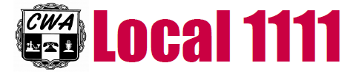
CWA Local 1111 Scholarship Fund
CWA Local 1111 will give out four $1,000.00 scholarships: One for the Eastern District.
One for the Western District.
One for the Healthcare District.
One for the Public Sector District.

Any natural or adopted child or children of active members in good standing of Local 1111 who have been accepted for enrollment as a full-time student in education above the high school level are eligible to apply. Proof of enrollment is required along with a 500 word essay on “How has the Union affected your life”.

The deadline to apply is May 31, 2020.

Winners will be chosen by the Executive Board in the form of a lottery drawing if all criteria is met. Please fill out the form below and return it with the essay and proof of college enrollment to our Union Hall: (The $1,000.00 will be paid directly to the recipients college or school.)

CWA Local 1111 Scholarship
459 East Church Street
Elmira, NY 14901-9977

Name: ______________________________College:___________________

Address: ______________________________________________________

_____________________________________________________________

Parent Name: __________________________________________________

Employed by: __________________________________________________

